June/July 2018
Murph Recap
KidFit
Ignite
Bring-A-Friend
OLY
Independence Day Hours
CFP Turns 5
Lift-Off
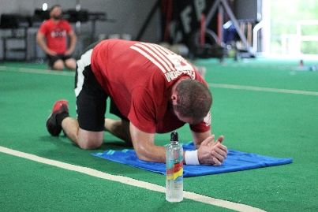
MURPH Recap
This year, we couldn’t have asked for nicer weather for the hardest workout we do all year! But in true Penance fashion, y’all showed up and showed out. The community was awesome. We added Stuff in a Bun and a keg of Meddlesome Breweries finest to refuel everyone post-WoD (although we did lose the food truck a little early). Thank you to everyone who came early or stayed late to cheer on fellow members as they suffered through the hero WoD.
As always, feedback is appreciated with everything we do, so if there was something we totally knocked out of the park, or something we could have done just a little bit better, please let us know!
KidFit
Good habits are ones that start early and are practiced often. As members of CFP, you know how important healthy lifestyle habits are. We want to help you and your families with our new KidFit class. We tried it out over Spring Break and the kids loved it. So, Steph got certified as a CrossFit Kids coach! (Since she’s certified, we are working on getting certified with CrossFit HQ as an official CrossFit Kids affiliate.) We are so excited to offer this class to help kids enjoy fitness and learn to make healthy habits a priority. Classes will be limited to 10 kids ages 5 – 12. Classes meet Mondays and Wednesdays at 5pm. KidFit is $100/month for members, $125/month for non-members. June is full, but make sure you register early to reserve your little one’s spot for July!
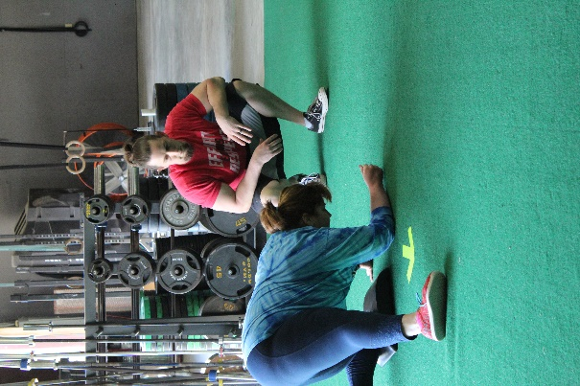
Ignite
We have made some exciting changes to our Ignite Fitness program. In addition to the 5:30 class, we are adding classes at 4:30 and 6:30 on Tuesdays and Thursdays.
Rachel is also joining the class, and her and Ginnie will co-coach. With the class only being 30 minutes long, we decided the addition of a second set of eyes and the fact that this is a beginner’s class focusing on form and technique would benefit all our brand-new athletes.
We are also including our Ignite Athletes in Bring-A-Friend week. For Bring-A-Friend week, Ignite Athletes are invited to join the 10am Saturday class and invite their friends to try us out without a drop-in fee. Bring-A-Friend Saturday is the 23rd of June and the 21st of July.
Bring-A-Friend
Bring-A-Friend week for June is the 18th through the 23rd, and the 16th through the 21st for July. The drop-in fee is waived for the CrossFit program only.
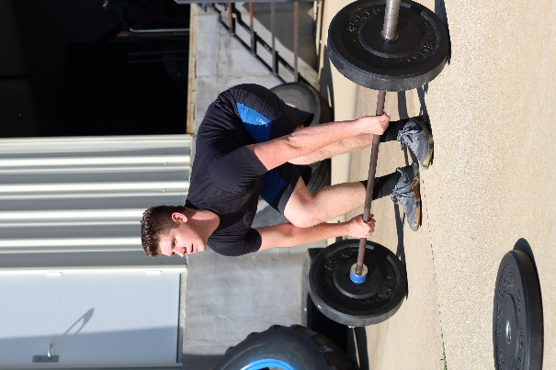
OLY
Olympic Lifting has come to Oakland! 7/7/2018 will be the start of the first 6-week OLY cycle. Jeremy will teach 10 lucky people the finer points of the Snatch and the Clean and Jerk. For those who are already signed up to participate in the Lift-Off, this is the perfect opportunity to get ahead of the competition with the Clean and Jerk (spoiler alert - it’s one of the movements for the Lift-Off). Class is $150 and will run for 6 consecutive Saturdays at 11am. No need to purchase any extra stuff for this class – just no tennis shoes, or shoes with padding under the feet. If you don’t already own lifting shoes, the best shoes for this class are shoes with flat soles and heels (like Chuck’s). If you have neither, barefoot is also an option. Class will fill up fast, so reserve your spot today. But don’t worry if you don’t get in for this first cycle, we will offer this as an on-going class.
Independence Day Hours
For July 4th this year, the gym will only be open for morning classes – 6, 8, 9, and we’re adding 10am to give everyone a 4th opportunity to get their sweat on.
CFP turns 5!!!
50% of small businesses fail to make it to their 5-year anniversary in business. To celebrate this awesome accomplishment, Clint and Rachel are hosting a cook-out at the farm. Burgers are on the boss, but if you want a different protein please feel free to bring it. Sides and desserts will be potluck-style. There’ll be a sheet posted on the corkboard for everyone to write down what they’re bringing.
The pool will be open, so bring your suits, sunscreen, lawn chairs and be ready to have a good time!
Lift-off
We are planning a lifting competition for October 20th. It was originally scheduled for September 22nd, but with Jeremy’s OLY class taking a 3 week hiatus between cycles, we would have to scrap an entire cycle, and we wanted as many members as possible to be able to have the opportunity to take the class to prepare for the Lift-Off.
Clint wants to do a practice run this summer to see how many people we can have lifting heavy weight at the same time. If anyone is interested in participating in the practice session, please let us know in the front office.
The date for the practice session is July 14th.

